Article ID: 7241
Article Name: Bad or no suction in my battery vacuum cleaner
Topic Location: floorcare, battery cleaner, usage, performance suction
Meta-data: low, insignificant, flow,
Related Articles:
Related Questions:
PNC
DIY
Safety
Link
Email
Book Engineer
Multimedia
Brand
Article Content:
The performance in a battery cleaner is very depending of the maintenance and cleaning of filters and brush rolls etc. To maintain good performance keep your cleaner clean.
If your battery cleaner has bad or low performance, always start with charging it overnight to have 100% battery power.
On standard battery cleaners the main cause for bad suction is clogged filters. Clean filters in dust container regularly. Most filter systems in battery cleaners have double filters, first a course filter and inside that a fine filter. It’s easy to forget to separate these two when cleaning and this results in reduced suction performance.
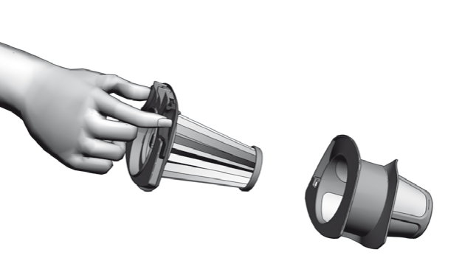
On a stick cleaner the brush roll has a big part in the performance, if it´s not rotating properly or is clogged the cleaning results will get reduced.
Clean the brush roll regularly and check that no fine tread or hair is tangled in the motor drive wheel.
